Aim: Implementing the Sorting Algorithms

IDE: Visual Studio Code

Insertion Sort

Theory: -

Insertion sort is a sorting algorithm that places an unsorted element at its suitable place in each iteration.

Insertion sort works similarly as we sort cards in our hands in a card game.

We assume that the first card is already sorted then, we select an unsorted card. If the unsorted card is greater than the card in hand, it is placed on the right otherwise, to the left. In the same way, other unsorted cards are taken and put in their right place.

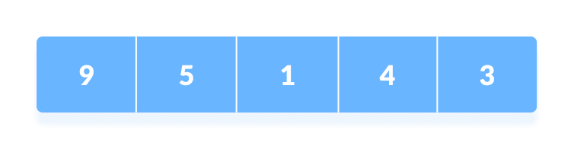
Working of Insertion Sort

The first element in the array is assumed to be sorted. Take the second element and store it separately in the key. Compare the key with the first element. If the first element is greater than the key, then the key is placed in front of the first element.
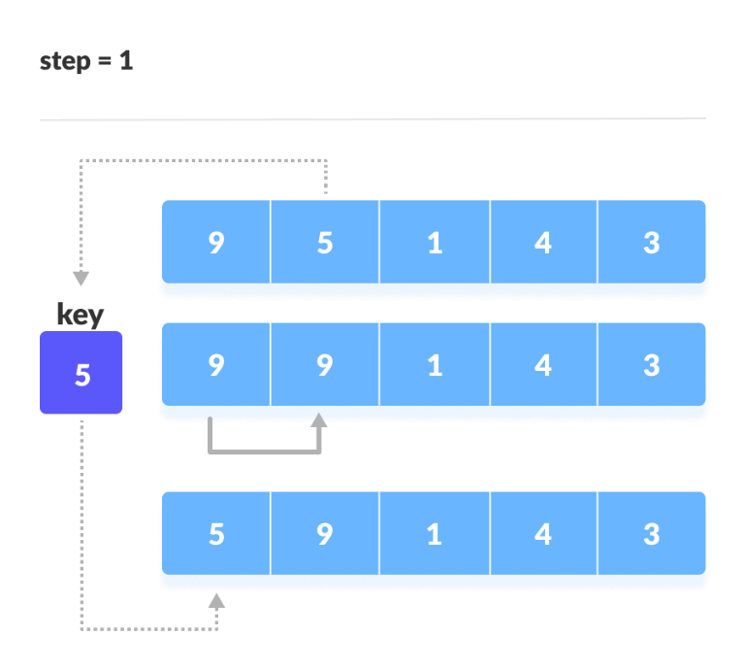

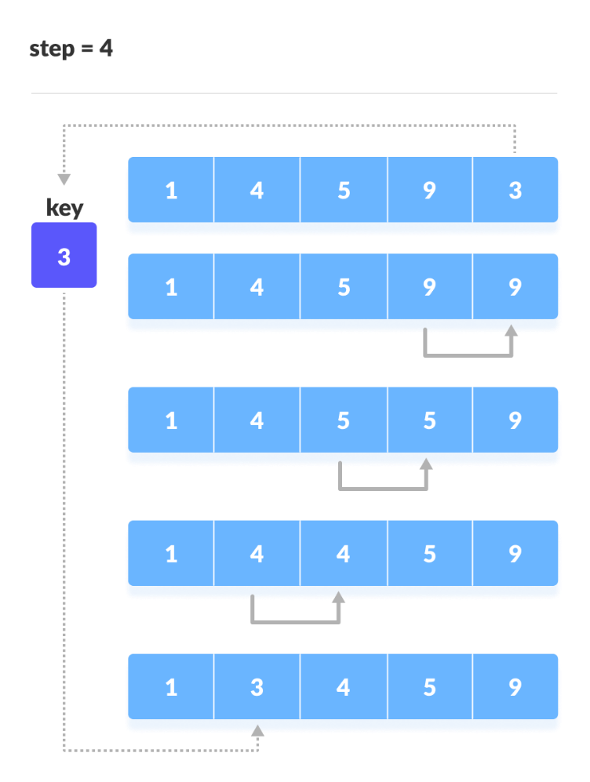
Now, the first two elements are sorted. Take the third element and compare it with the elements on the left of it. Placed it just behind the element smaller than it. If no element is smaller than it, place it at the beginning of the array.
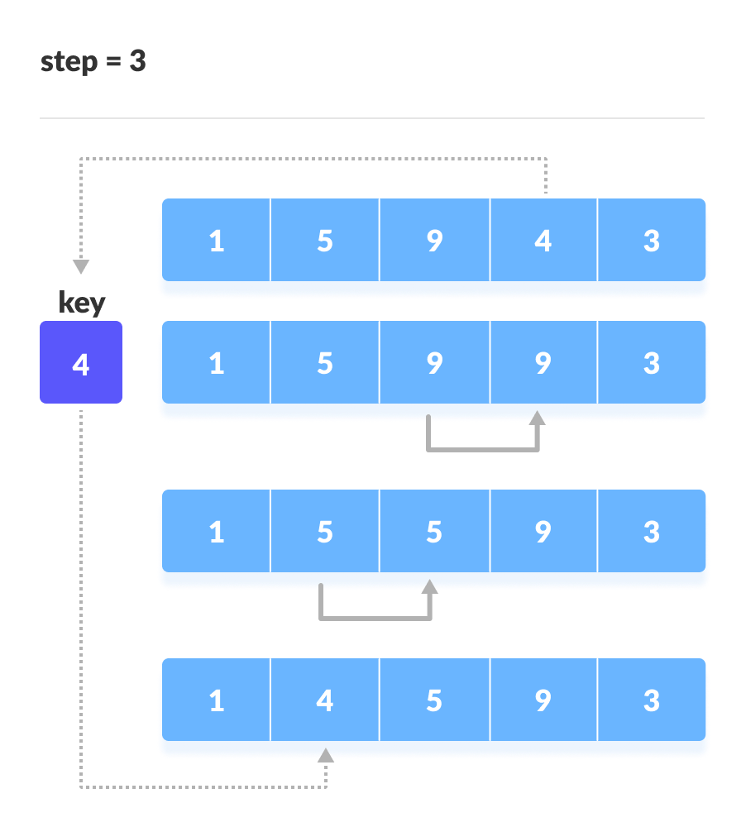

Programming Language: - C++

Code :-

#include<iostream>

#include <vector>

using namespace std;

void Print_Array(vector<int> Array) {

for (int i = 0; i < Array.size(); i++) {

cout << Array[i] << " ";

}

cout << endl;

}

void Insertion_Sort(vector<int>& Array) {

for (int i = 1; i < Array.size(); i++) {

int key = Array[i];

int j = i - 1;

while (j >= 0 && Array[j] > key) {

Array[j + 1] = Array[j];

j--;

}

Array[j + 1] = key;

}

}

int main() {

vector<int> Array = {12 ,45, 57, 78, 89, 62, 7, 49, 21, 23};

cout << "Array Before Sorting: - " << endl;

Print_Array(Array);

Insertion_Sort(Array);

cout << "Array After Sorting :- " << endl;

Print_Array(Array);

return 0;

}

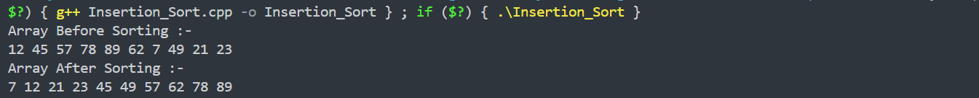
Output :-

Space Complexity:- O(1)
Justification: - Insertion Sort is an in-place sorting algorithm. It only uses one extra variable (key) and performs all shifting operations inside the same array. No additional data structures are created, so extra memory does not grow with input size. Therefore, the auxiliary space required is constant, i.e., O(1).
Best Case Time Complexity:- O(n)
Justification: - The best case occurs when the array is already sorted. In this situation, every iteration of the inner loop fails immediately (Array[j] > key is false), so no shifting takes place. Each element is compared only once. Hence, the total number of operations is proportional to n, giving a linear time complexity O(n).
Worst Case Time Complexity:- O(n²)
Justification: - The worst case occurs when the array is sorted in reverse order. For each element, the algorithm compares and shifts through all previously sorted elements. This produces a series of operations: 1 + 2 + 3 + … + (n−1) = n(n−1)/2, which is quadratic. Therefore, the worst-case time complexity is O(n²).

Bubble Sort

Theory: -

Bubble sort is a sorting algorithm that compares two adjacent elements and swaps them until they are in the intended order.

Just like the movement of air bubbles in the water that rise up to the surface, each array element moves to the end in each iteration. Therefore, it is called a bubble sort.

Working of Bubble Sort

First Iteration (Compare and Swap)

Starting from the first index, compare the first and the second elements.

If the first element is greater than the second element, they are swapped.

Now, compare the second and the third elements. Swap them if they are not in order.

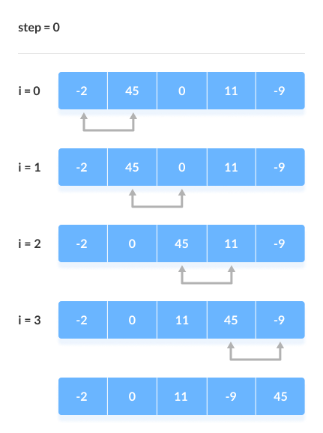
The above process goes on until the last element

Remaining Iteration

The same process goes on for the remaining iterations.

After each iteration, the largest element among the unsorted elements is placed at the end

Programming Language: - C++

Code :-

#include<bits/stdc++.h>

using namespace std;

void Print_Array(vector<int> Array) {

for (int i = 0; i < Array.size(); i++) {

cout << Array[i] << " ";

}

cout << endl;

}

void Swap(int& x, int& y) {

int temp = x;

x = y;

y = temp;

}

void Bubble_Sort(vector<int> &Array) {

int size = Array.size();

for (int i = 0; i < size - 1; i++) {

bool Swapped = false;

for (int j = 0; j < size - i - 1; j++) {

if (Array[j] > Array[j + 1]) {

Swap(Array[j], Array[j + 1]);

Swapped = true;

}

}

if (Swapped == false) {

break;

}

}

return;

}

int main() {

vector<int> Array = { 12 ,45 , 57 , 78 , 89 , 62 , 7 , 49 , 21 , 23 };

cout << "Array Before Sorting :- " << endl;

Print_Array(Array);

Bubble_Sort(Array);

cout << "Array After Sorting :- " << endl;

Print_Array(Array);

return 0;

}

Output :-

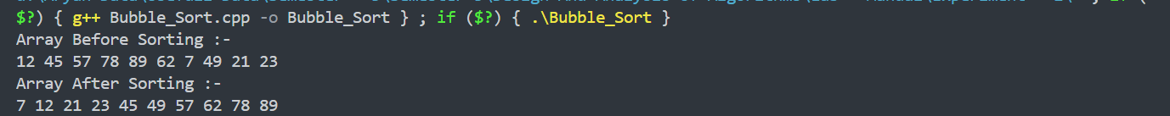
Space Complexity:- O(1)
Justification: - Bubble Sort is an in-place sorting algorithm. It performs swapping inside the same array and does not require any extra data structure whose size grows with input. Only a few variables (i, j, temp, Swapped) are used, all taking constant space. Therefore, the auxiliary space required is O(1).
Best Case Time Complexity:- O(n)
Justification: - The best case happens when the array is already sorted. In this implementation, the Swapped flag becomes false after the first pass, causing the algorithm to stop early. It only performs one full traversal with no swaps, making the time complexity O(n).
Worst Case Time Complexity:- O(n²)
Justification: - In the worst case (array sorted in reverse order), Bubble Sort compares and swaps every adjacent pair in each iteration. For n elements, it performs:( n−1 ) + ( n−2 ) + … + 1 = n(n−1)/2 comparisons and swaps.This forms a quadratic progression, leading to a worst-case time complexity of O(n²).
Counting Sort

Theory: -

Counting sort is a sorting algorithm that sorts the elements of an array by counting the number of occurrences of each unique element in the array.

The count is stored in an auxiliary array and the sorting is done by mapping the count as an index of the auxiliary array.

Working of Counting Sort

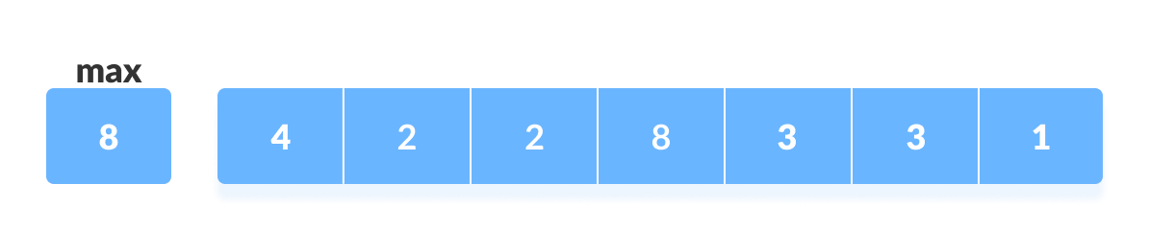
Find out the maximum element (let it be max) from the given array.

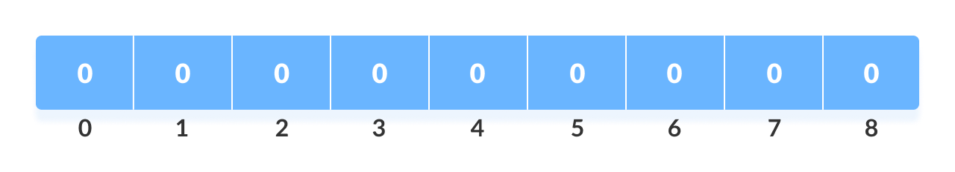
Initialize an array of length max+1 with all elements 0. This array is used for storing the count of the elements in the array.

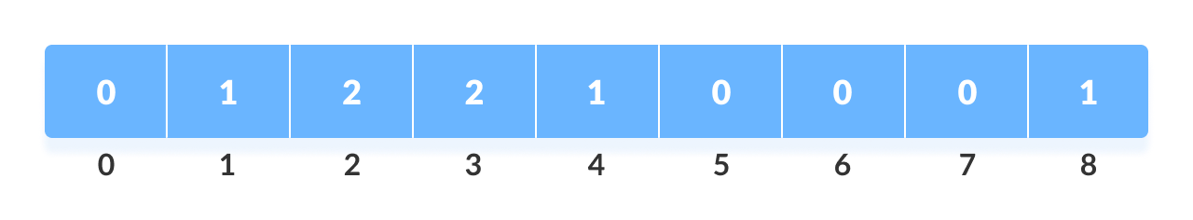
Store the count of each element at their respective index in count array

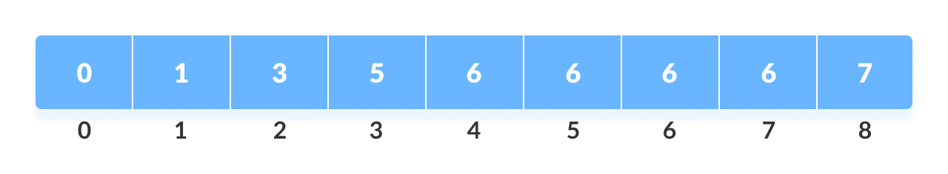
Store cumulative sum of the elements of the count array. It helps in placing the elements into the correct index of the sorted array.

Find the index of each element of the original array in the count array. This gives the cumulative count. Place the element at the index calculated.
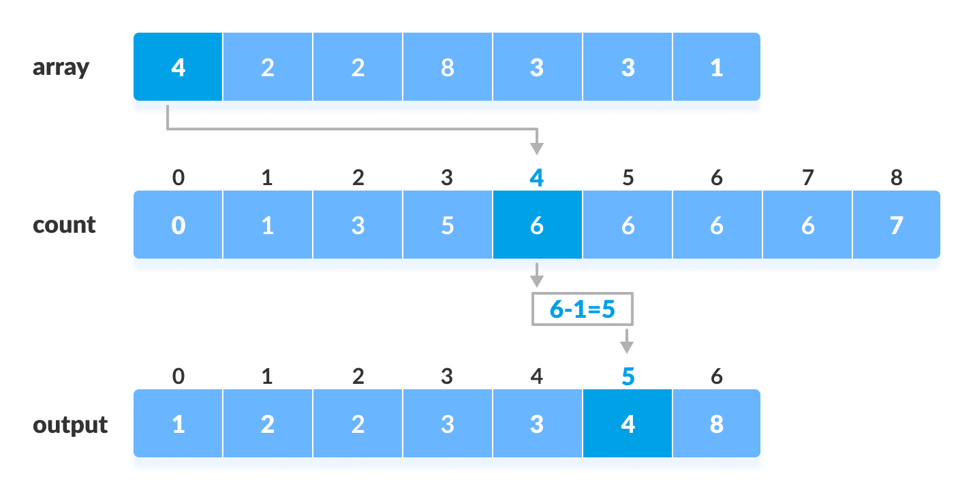

Programming Language: - C++

Code :-

#include<iostream>

#include<vector>

using namespace std;

void Print_Array(vector<int> Array) {

for (int i = 0; i < Array.size(); i++) {

cout << Array[i] << " ";

}

cout << endl;

}

int Find_Max(vector<int> Array) {

int max_num = Array[0];

for(int i = 1; i < Array.size(); i++) {

if(Array[i] > max_num) {

max_num = Array[i];

}

}

return max_num;

}

void Counting_Sort(vector<int>& Array) {

int max_num = Find_Max(Array);

vector<int> count(max_num + 1, 0);

for (int i = 0; i < Array.size(); i++) {

count[Array[i]]++;

}

int index = 0;

for (int i = 0; i <= max_num; i++) {

while (count[i] > 0) {

Array[index++] = i;

count[i]--;

}

}

return;

}

int main() {

vector<int> Array = { 12 ,45 , 57 , 78 , 89 , 62 , 7 , 49 , 21 , 23 };

cout << "Array Before Sorting :- " << endl;

Print_Array(Array);

Counting_Sort(Array);

cout << "Array After Sorting :- " << endl;

Print_Array(Array);

return 0;

}

Output :-
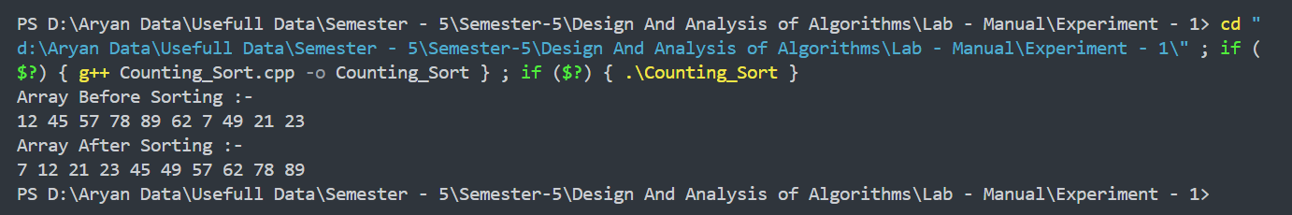

Space Complexity:- _________
Justification: - ________________________________________________________________________________________________________________________________________________________________________________________

Time Complexity:

Best Case Time Complexity: _________
Justification: - ________________________________________________________________________________________________________________________________________________________________________________________

Worst Case Time Complexity:- ___________
Justification: - ________________________________________________________________________________________________________________________________________________________________________________________

Selection Sort

Theory: -

Selection sort is a simple and efficient sorting algorithm that works by repeatedly selecting the smallest (or largest) element from the unsorted portion of the list and moving it to the sorted portion of the list.

The algorithm repeatedly selects the smallest (or largest) element from the unsorted portion of the list and swaps it with the first element of the unsorted part. This process is repeated for the remaining unsorted portion until the entire list is sorted.

Working of Selection Sort

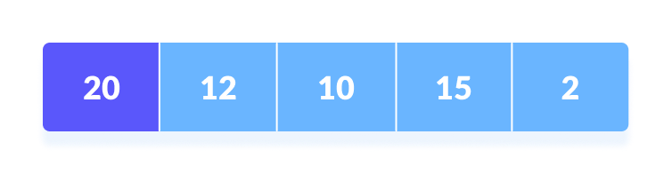
Set the first element as a minimum.

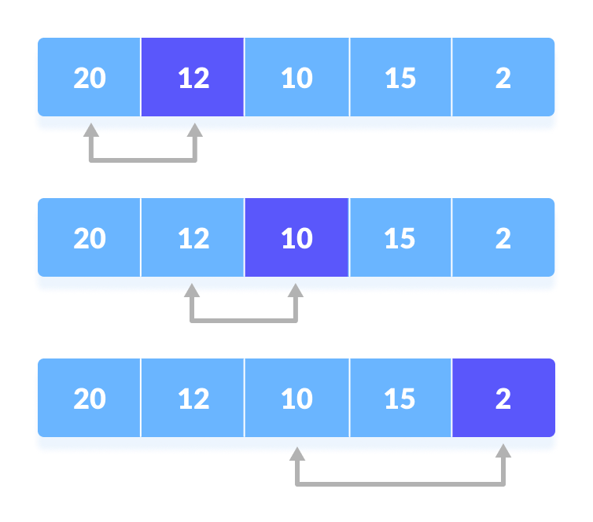
Compare the minimum with the second element. If the second element is smaller than the minimum, assign the second element as the minimum. Compare minimum with the third element. Again, if the third element is smaller, then assign a minimum to the third element otherwise do nothing. The process goes on until the last element.

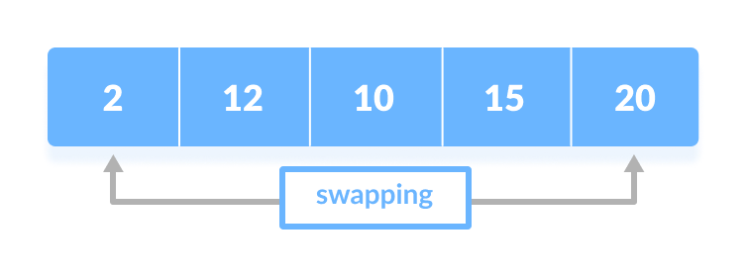
After each iteration, the minimum is placed in the front of the unsorted list.

For each iteration, indexing starts from the first unsorted element. Step 1 to 3 are repeated until all the elements are placed at their correct positions.
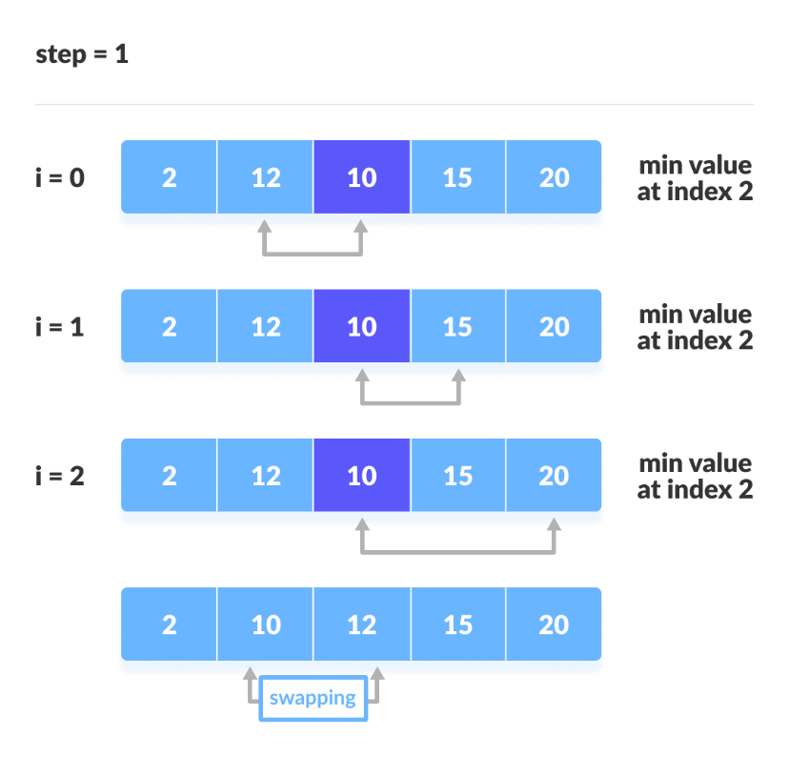
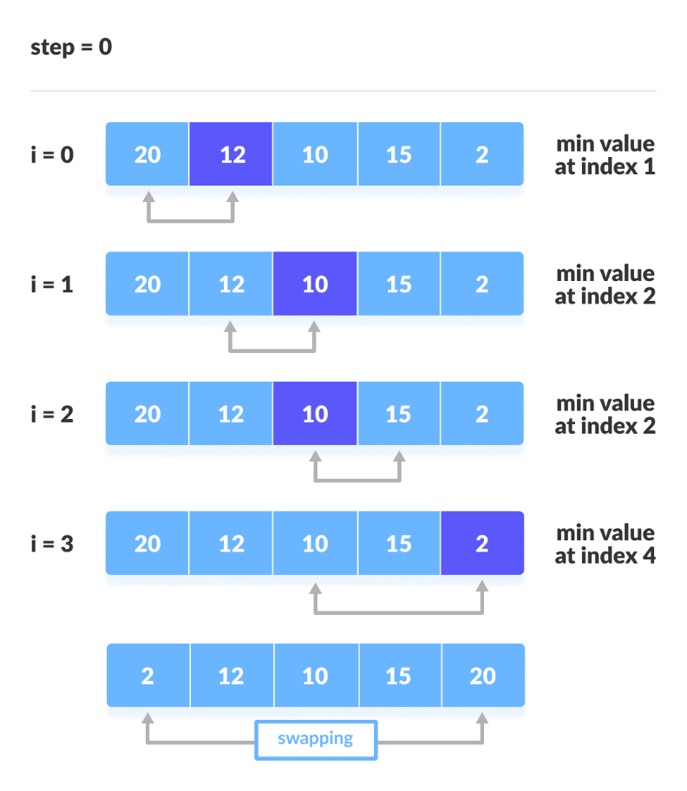

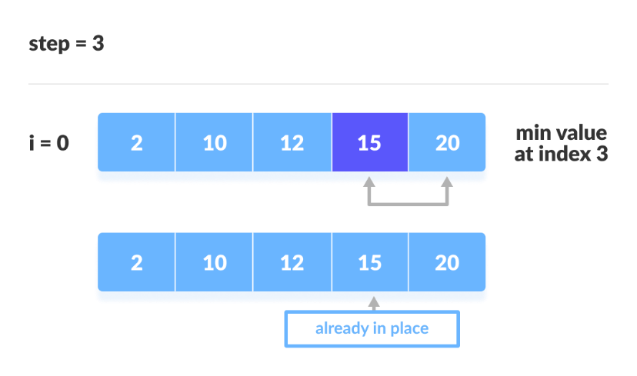
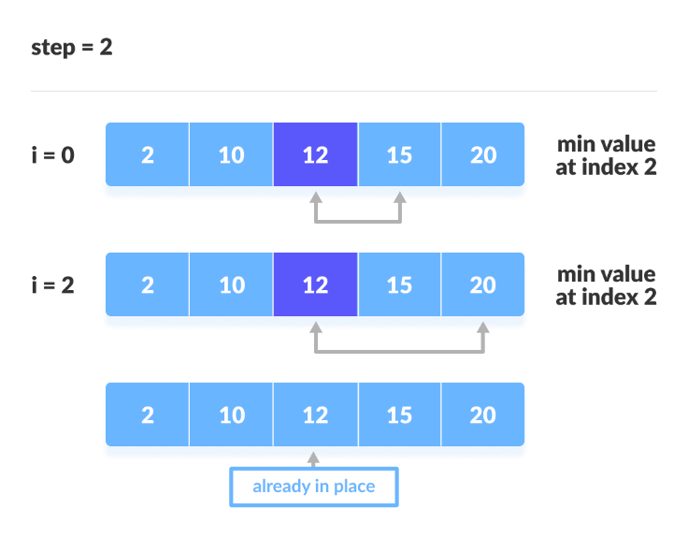

Algorithm: -

__________________________________________________________________________________________________________________________________________________________________________________________________________________________________________________________________________________________________________________________________________________________________________________________________________________________________________________________________________________________________________________________________________________________________________________________________________________________________________________________________________________________________________________________________________________________________________________________________________________________________________________________________________________________________________________________________________________________________________________________________________________________________________________________________________

________________________________________________________________________________________________________________________________________________________________________________________________________________________________________________________________________________________________________________________________________________________________________________________________________________________________________________________________________________________________________________________________________________________________________________________________________________________________________________________________________________________________________________________________________________________________________________

Programming Language: - C++

Code :-

#include<iostream>

#include<vector>

using namespace std;

void Print_Array(vector<int> Array) {

for (int i = 0; i < Array.size(); i++) {

cout << Array[i] << " ";

}

cout << endl;

}

void Swap(int& x, int& y) {

int temp = x;

x = y;

y = temp;

}

void Selection_Sort(vector<int>& Array) {

for(int i = 0; i < Array.size(); i++) {

int min_index = i;

for (int j = i + 1; j < Array.size(); j++) {

if (Array[j] < Array[min_index]) {

min_index = j;

}

}

Swap(Array[i], Array[min_index]);

}

return;

}

int main() {

vector<int> Array = { 12 ,45 , 57 , 78 , 89 , 62 , 7 , 49 , 21 , 23 };

cout << "Array Before Sorting :- " << endl;

Print_Array(Array);

Selection_Sort(Array);

cout << "Array After Sorting :- " << endl;

Print_Array(Array);

return 0;

}

Output :-
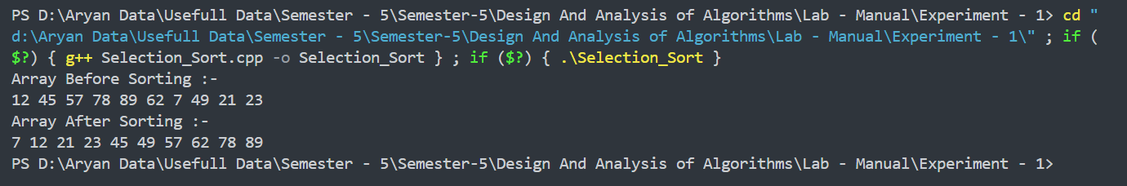

Space Complexity:- _________
Justification: - ________________________________________________________________________________________________________________________________________________________________________________________

Time Complexity:

Best Case Time Complexity: _________
Justification: - ________________________________________________________________________________________________________________________________________________________________________________________

Worst Case Time Complexity:- ___________
Justification: - ________________________________________________________________________________________________________________________________________________________________________________________

Conclusion:-

________________________________________________________________________________________________________________________________________________________________________________________

________________________________________________________________________________________________________________________________________________________________________________________

________________________________________________________________________________________________________________________________________________________________________________________

